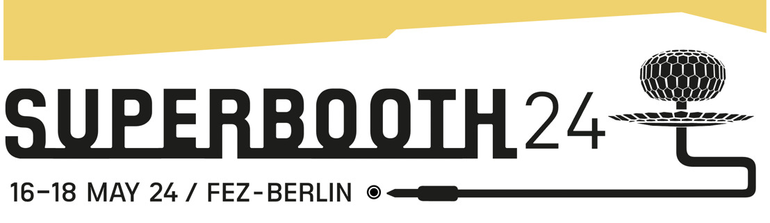

# Get a Sneak Peek of *THE MINIMOOG BOOK* at Superbooth ‘24

*Publisher Kim Bjørn will be at Booth O115 with never-before-seen materials from the latest Bjooks title on the Minimoog synthesizer — now available to pre-order on Kickstarter.*

**Berlin, Germany, May 15, 2024** — Danish independent book publisher [Bjooks](https://u14456542.ct.sendgrid.net/ls/click?upn=u001.0i-2FJ-2FedkxMGDABIl5kmwiPPkuL-2Fy9xz6dTa4Hrnyxtw-3DCJdK_-2Fa7tUViJZo-2BwdGxm1M2lA0HjtVgga76-2FU77aHNfri9EP1zXfJcFeSUteaA5elM9BRi278uiRqh-2FCpUAf5hBTmgm5EyU6FoTXbCuCupB0c3vIC2RUvRvcJDO1pKCdCzGoRFRd-2FcaEZhRuTtM70wf3F26CVQcjdcuZXJS2jSOv44jcZEDy-2FQHm4eE1ttl6969-2F3BergUcZFopTDdKou7OdH9X7hML6MvuCcII-2FWzwmuneM3djAXu-2BtF5OfFJWaFBMp68umSxNBjTg2bM-2BX-2BctKsM1cEvYo-2Fd823c5Th5JCZrp-2BQwwgowKHnMuMK8e7nWxujtdPfbTxWO0WY5OLIlrm3Khy3-2FIkp8Tgeq1gcdxdUfcszhLVcc38vtlgTy6K98P7s-2B4z-2BuEYEeomJGYI3d-2BfopByOaFZlPRwyiAdoXiPjhpGHOR61H-2FwamQIleGDDttB3rEICtZ8cuZCBZwhEExTsLZAWJeS2mjFxRf4lIGeUlE-3D" \t "_blank) has announced their presence at this week’s Superbooth event in Berlin, Germany, from the 16th to 18th of May 2024.

Bjooks founder Kim Bjørn will be on site — with a Voyager XL and Model D — at Booth O115 to debut the company’s newest title: [a comprehensive look into the history and legacy of the Minimoog synthesizer](https://www.kickstarter.com/projects/bjooks/the-minimoog-book).

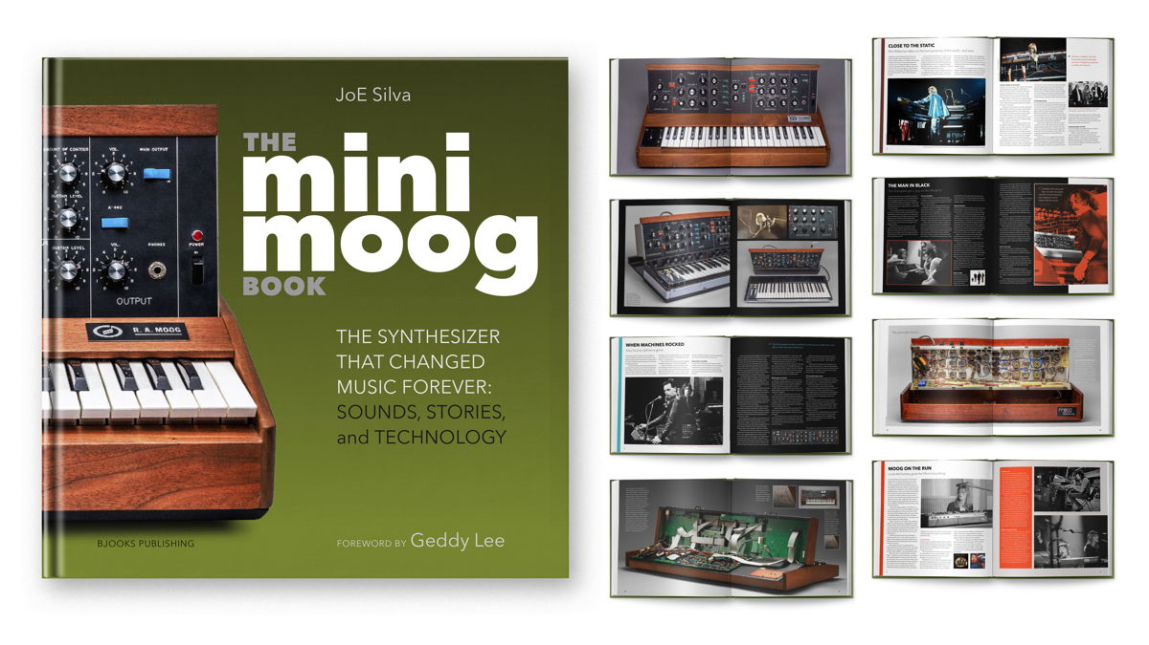

A beautiful hardcover coffee table book that includes nearly 400 full-color pages, [*THE MINIMOOG BOOK*](https://www.kickstarter.com/projects/bjooks/the-minimoog-book) delivers surprise and delight on every page for electronic music lovers and synth enthusiasts.

Superbooth attendees can stop by the Bjooks space for an exclusive look into this monumental work that is being funded [through Kickstarter](https://www.kickstarter.com/projects/bjooks/the-minimoog-book) through the end of May.

Plus, enjoy live performances by talented musicians supporting Bjooks’ efforts to make this book a reality.

* [Oora (IT)](https://ooramusic.com/)
* [Nadia Struiwigh (NL)](https://nadiastruiwigh.com/)
* [Hataken (JP)](https://hataken.info/)
* [Surco (US)](https://soundcloud.com/surcolive)
* [Jens Paldam (DK)](https://modular-station.com/artists/jens-paldam/)
* [Scott Harper aka Knobs (US)](https://www.knobscreative.com/)

Bjørn will have an array of some of his favorite instruments from beloved brands and makers set up for visitors to explore, as well.

* [Moog Music](https://www.moogmusic.com/)
* [Erica Synths](https://www.ericasynths.lv/)
* [Torso Electronics](https://torsoelectronics.com/)
* [Chase Bliss Audio](https://www.chasebliss.com/)

Come try out a Minimoog Voyager XL and Model D — and don't miss the opportunity to take an exclusive look inside *THE MINIMOOG BOOK*. Visit Booth O115, just above the main building entrance at FEZ-Berlin, to meet the musician, designer, and publisher behind this work and many other industry favorites like *PATCH & TWEAK*and*SYNTH GEMS*.

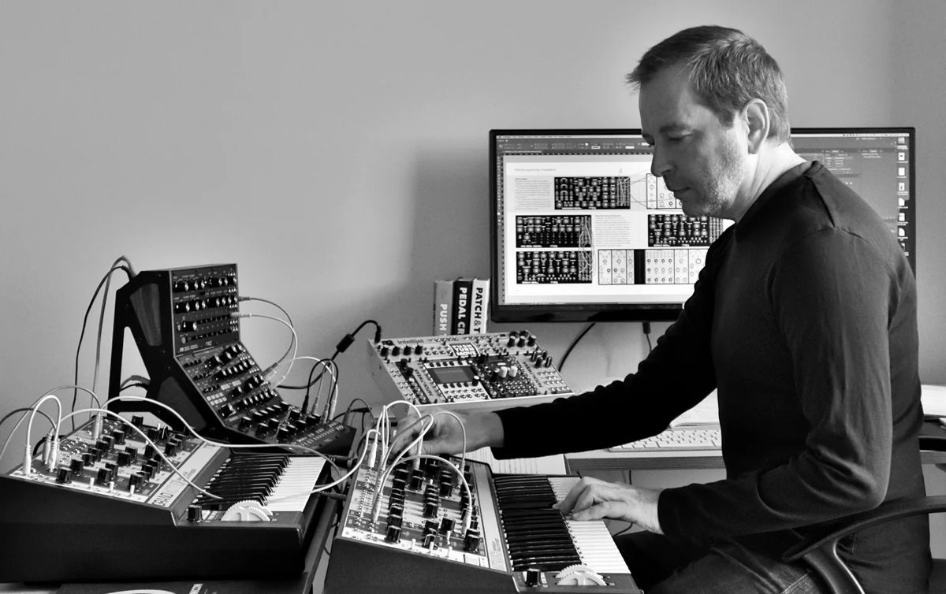

**COMING SOON: Bjooks Cub  
​**Weekly podcast episodes, exclusive patch tips, new videos, custom keepsakes, special offers, and in-depth extras from *THE MINIMOOG BOOK* and other titles are coming soon — with a special intro offer for all Kickstarter backers.

The new **Bjooks Club**is a new community for electronic music fans and makers. Get updates on projects you support, learn what’s new in the synth space, and get perks like eBook versions of all Bjooks titles. Visit [bjooks.com/club](https://bjooks.com/club) for more information on how to join.  
​

**About Bjooks  
​**Bjooks is a boutique music tech publishing company started by author, designer, and musician Kim Bjørn. His first book, *PUSH TURN MOVE*, was published in 2017. This was followed by *PATCH & TWEAK* in 2018, which has since been referred to as the “Bible of Modular Synthesis.” Subsequent titles include *PEDAL CRUSH*(2019), *PATCH & TWEAK with Moog* (2020), *SYNTH GEMS 1* (2021), *PATCH & TWEAK with KORG* (2022), and *INSPIRE THE MUSIC*, released in cooperation with Roland Corp. on its 50th anniversary in 2022. Bjooks’ latest work, *THE MINIMOOG BOOK*, is now available to pre-order. Learn more at [bjooks.com](http://bjooks.com/)**.  
​**